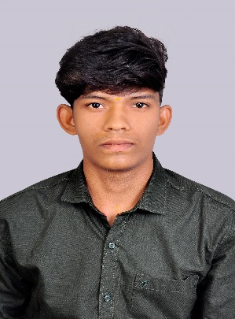 **VIJAYAKUMAR R**

**Email :** cecsvijayakumar25@gmail.com

**Contact :** +91 9003694806

**Address :** 8/1,

Thambi kalai iyyan kovil,

Thaneer panthalpalayam(PO),

Perundurai(TK),

Erode-638116.

**Linkedin :** <https://www.linkedin.com/in/vijayakumar-r-598584269>

**GitHub :** https://github.com/vijayakumarCSE25

**CAREER OBJECTIVE :**

Continuously enhance my coding skills and expand my knowledge by exploring cutting-edge technologies, frameworks, and languages. Apply this expertise effectively to develop efficient, scalable, innovative software solutions.

**ACADEMIC PROFILE :**

* **BE Computer Science (2025)** – K.S.R College of Engineering

**CGPA**-**7.1** (upto 6TH sem)

* **HSC (2021) –** Sri Venkateshwara Vidhayalayaa Higher Sec. School

**Percentage - 76%**

* **SSLC (2019 ) –** TNK High School

**Percentage - 62%**

**AREA OF INTERESTS :**

* Web Development

**PROJECTS :**

* Created a personal portfolio using HTML, CSS and JavaScript.
* Created a weather Web application using HTML,CSS and JavaScript
* Created a stop-watch Web application using HTML,CSS and JavaScript.

**TECHNICAL SKILL SETS :**

* Front End : HTML, CSS
* Java

**LANGUAGES KNOWN :**

* English
* Tamil

**CO-CURRICULAR ACTIVITIES :**

* Completed the Salesforce Developer Virtual Internship on February 2024.
* Participated in the workshop presentation at Knowledge Institute of Technology March 2023, **Title :** “Frontend Mania”
* Participated in the paper presentation at Coimbatore Institute of Technology on March 2024, **Title :** “Artificial Intelligence”

**INDUSTRY DRIVEN COURSES :**

* Completed Getting Started With Azure DevOps Boards in Coursera on September 2023.
* Completed Cloud computing course in NPTEL on November 2023.
* Completed Introduction to Industry 4.0 and Industrial Internet of Things NPTEL on April 2024 .

**EXTRA-CURRICULAR ACTIVITIES :**

* Secured Second prize in the in zonal Kabaddi tournament conducted in TNK High School 2018.
* Secured third place in Photography in Media Club Activity by K.S.R. college of Engineering in April 2023.

**PERSONAL PROFILE :**

Father’s Name : Mr.Ramasamy P

Mother’s Name : Mrs.Rathna R

Date of Birth & Age : 26.03.2004 & 20 years

Nationality : Indian

Hobbies : Photograpy and Adobe Photoshop Editing

**DECLARATION :**

I hereby declare that above furnished details are true to be best of my knowledge.

**PLACE:** Tiruchengode **(VIJAYAKUMAR R )**